Project Design Phase-II
Technology Stack (Architecture & Stack)

Date | 19October 2022
Team ID | PNT2022TMID02425
Project Name | Project – Web Phishing Detection
Maximum Marks | 4 Marks

Technical Architecture:

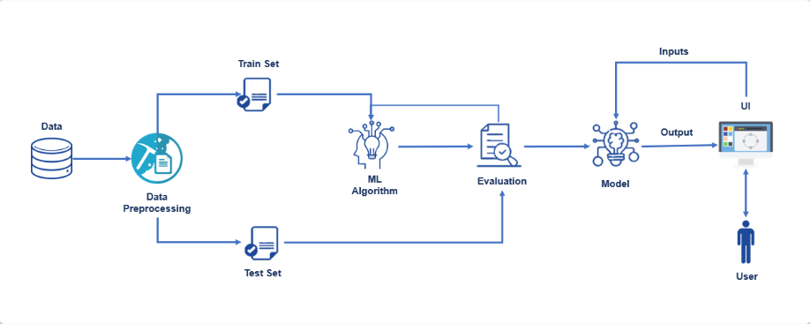

Table-1 : Components & Technologies:
S.No | Component | Description | Technology
 | User Interface | How user interacts with application e.g.  Web UI, Mobile App, Chatbot etc. | HTML, CSS, JavaScript / Angular Js / React Js etc.
 | Application Logic-1 | Logic for a process in the application | Java / Python
 | Application Logic-2 | Logic for a process in the application | IBM Watson STT service
 | Application Logic-3 | Logic for a process in the application | IBM Watson Assistant
 | Database | Data Type, Configurations etc. | MySQL, NoSQL, etc.
 | Cloud Database | Database Service on Cloud | IBM DB2, IBM Cloudant etc.
 | File Storage | File storage requirements | IBM Block Storage or Other Storage Service or Local Filesystem

Table-2: Application Characteristics:
S.No | Characteristics | Description | Technology
 | Open-Source Frameworks | Gopish is a powerful, open-source phishing  framework that makes it easy to test your  organization's exposure to phishing. | Machine learning
 | Security Implementations | Our prototype includes a c#.Net framework implementation of a web browser. | Cofense PDR (Phishing Detection and  Response)
 | Scalable Architecture | Scalability is maximum due to accurate estimation | jQuery,cloud flare, Bootstarp
 | Availability | Mostly available methods for detecting phishing  attacks are blacklists/whitelists, natural language  processing, visual similarity, rules, machine  learning techniques | Wireshark, Ghost phisher,king phisher
 | Performance | We assessed the performance of the phishing  classification models employing accuracy,  precision, recall and F-score. | Hardware and support systems,software applications

